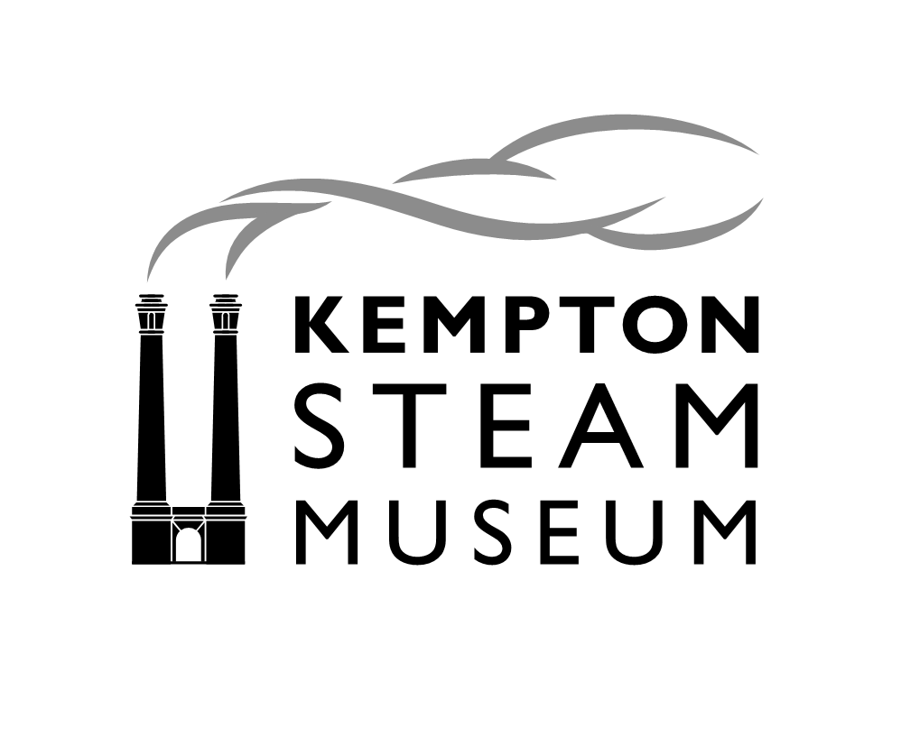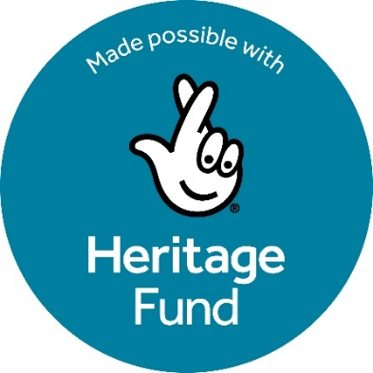
Role Title: Museum Operations and Project Manager
Reports To: Board of Trustees (Kempton Great Engines Trust)
Role Purpose: To manage the day-to-day operations of the museum while also overseeing our project: Kempton: Clean Water for Life - reaching a wider audience. This project is made possible with The National Lottery Heritage Fund. Thanks to National Lottery players, we aim to transform Kempton Steam Museum’s engagement with visitors and the local community, while enhancing support for volunteers and care of collections. Three new part-time staff roles are being created to focus on volunteering, collections and managing the project.
This role’s key aims are to ensure that the museum runs smoothly and that the Heritage Fund Project is completed on time and within budget.
Key Responsibilities:
- Operations Management:
  - Overseeing the daily operations of the museum, in particular to build capacity in collaboration with the Operations Committee, including visitor services, facility management, and security.
  - Ensure a safe, accessible, and welcoming environment for all visitors
  - Develop and implement operational policies and procedures
- Heritage Fund Project Coordination:
  - Plan, execute, and monitor all aspects of the Heritage Fund Project
  - Coordinate with internal and external stakeholders to ensure successful project delivery.
  - Track project timelines, budgets, and deliverables and report as required to Trustees and Heritage Fund
  - Ensure evaluation of the project is carried out to Heritage Fund guidelines
- Staff and Volunteer Coordination:
  - Line manage the Volunteer Coordinator to ensure that the museum is adequately resourced for both visitor-facing and engineering volunteers
  - Foster a positive and collaborative working environment between staff and volunteers
- Curatorial Coordination:
  - Line manage the Curatorial Assistant to ensure that the museum’s collections are looked after and documented in accordance with best practice
  - Work with the Curatorial Assistant and trustees to attain Museum Accreditation with the Arts Council by August 2026, providing particular support on the sections concerning strategic planning, marketing and visitor experience
- Management of consultants:
- Work with the Trustees to recruit a consultant to develop an audience development strategy as part of the Heritage Fund Project; manage the consultancy from inception to final report, reporting to Trustees and Heritage Fund as required
- Work with the Trustees to recruit a learning consultant to develop digital materials for Key Stages 1 & 2; manage the consultancy from inception to final report, reporting to Trustees and Heritage Fund as required
- Visitor Experience:
  - Enhance the visitor experience by implementing visitor feedback and improving services
  - Ensure that visitor enquiries, feedback, and special requests are handled in a professional manner
  - Ensure high standards of customer service and assist in training of front of house volunteers as necessary
Qualifications and Skills:
- Strong organisational and project management skills
- Excellent communication and interpersonal skills
- Experience in operations and project management in museums, heritage sites or a related cultural field
- Ability to manage multiple tasks simultaneously
Personal Attributes:
- Proactive and detail-oriented.
- Strong problem-solving skills and the ability to handle challenging situations
- Enthusiastic and passionate about museum work, heritage and engaging diverse audiences
- Flexible and adaptable to changing needs and priorities
Salary:
£30,000 per annum pro rata (2 days per week, 16 hours), equivalent to £12,000 per annum.
Flexible hours; some weekend work required. While some tasks can be completed remotely, much of the role requires on-site presence.

