**Ealing Roots & Wings**

**Peer Research Programme**

**Programme Outline**

Ealing Roots and Wings is a programme for Black-led community organisations in Ealing which support health and wellbeing within the local population. There are ten spaces for eligible organisations for our 2025 programme.

The Peer Research part of the programme provides participants, many of whom bring valuable experience from working within or as part of community organisations, the opportunity to lead peer research within their communities. The focus is on exploring the varied ways health inequalities impact your communities. It serves as a platform for these leaders to share their insights, leverage their organisational knowledge, exchange learnings, and collaboratively propose solutions to the challenges identified through their community-led research.

Each participant will have the opportunity to design their own research question that would form the basis of their research project. This question can be tailored specifically to an area of interest or focus based on overall health and wellbeing.

**What is Peer Research?**

A participatory research approach that involves individuals with lived experience of the issues being studied in directing and conducting the research. Peer researchers use their lived experience and understanding of a social or geographical community to help generate information about their peers for research purposes. They may be involved in assisting with research design, developing research tools, collecting and analysing data, or writing up and disseminating findings.

**What will the programme involve?**

* Attending training sessions in research
* Learning about and then using research methods as part of the project
* Carrying out research activity
* Maintaining accurate records and up-to-date monitoring information
* Reflecting on and sharing your findings with the local community
* Engaging in a co-analysis process based on the research
* Shaping the outputs of the project
* Paid the London Living Wage to take part in the training

**What will I learn as part of this training?**

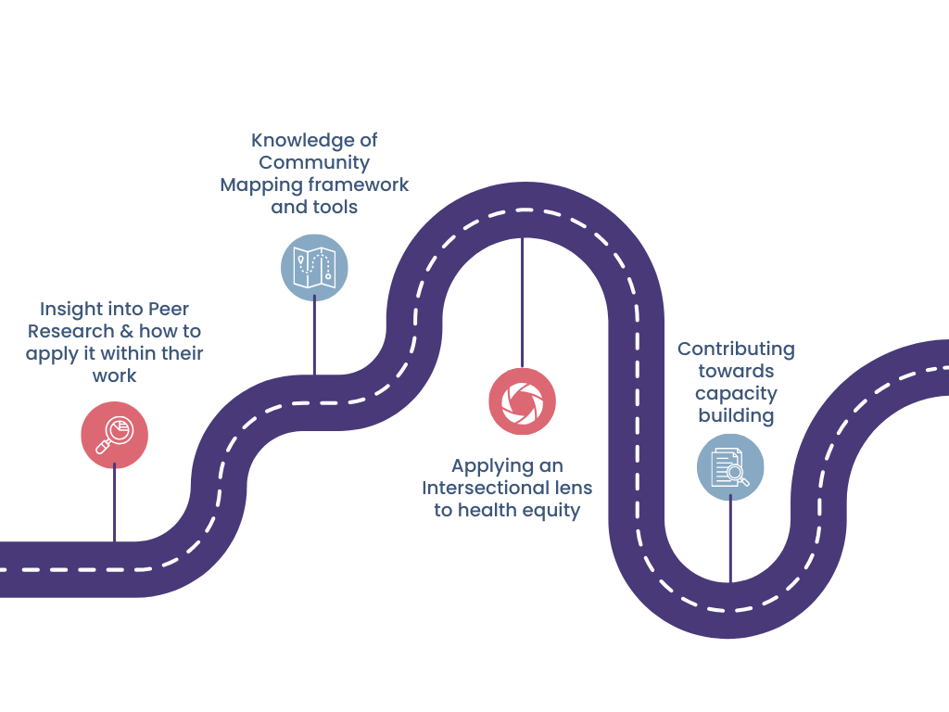

**This is in addition to the following:**

* **Research Design:** Understanding how to structure a research project, from identifying key questions to selecting appropriate methodologies.
* **Data Collection Techniques:** Developing skills in conducting interviews, facilitating focus groups and using community mapping.
* **Data Analysis:** Gaining knowledge in interpreting qualitative and quantitative data to identify trends, themes, and key findings.

**What are some of the benefits of being part of this programme?**

* Gaining the skills to present ideas and engage with stakeholders effectively.
* Using personal and community insights to drive systemic change
* Connecting with other community leaders, organisations, and stakeholders.
* Learning to design and conduct community-focused research using a range of methodologies, such as interviews, surveys, and focus groups.

**Timeline:**

The training will aim to take place from April 2025 with exact timings being confirmed once organisations have received confirmation about application outcomes.

**About Voices of Colour:**

[Voices of Colour](http://www.voicesofcolour.org/) is a research and community action organisation that addresses systemic inequities and provides a platform to amplify the voices of Global Majority communities. We deliver community research programmes, with a focus on co-designing spaces, provisions and policies. The platform we provide is the beginning of a journey to create more meaningful conversations and change around issues that are impacting communities. It’s a space to bring these communities together to initiate that change and re-imagine spaces where they feel heard.