|  |  |  |  |  |
| --- | --- | --- | --- | --- |
| ***September***  ***2024***  Cartoon Birthday cards design vector 02 free downloadMonday 2  Brenda’s  Birthday Celebration and card making | | **Tuesday 3 Sept**  Singing and dancing to 60’s music  Elderly people isolated set illustration | **Wednesday 4 Sept**  Play dough character hi-res stock photography and images - Alamy  Art and Craft Using Playdo Making Dinosaurs  Dexterity | **Thursday 5 Sept**  Cartoon people quiz game show concept Royalty Free Vector      Time for Quizz |
| **Monday 9 Sept**  Making Paper Flowers  Cartoon Bouquet Images - Free Download on Freepik | | **Tuesday 10 Sept**  Group exercise with  Zarifa  Elderly people isolated set illustration | **Wednesday11Sept**  Wellbeing  Nail Cartoon Images - Free Download on Freepik Pampering Day | **Thursday 12 Sept**  Dinosaur Images - Free Download on FreepikPainting Dinosaurs made from Playdo  Art and Craft |
| **Monday 16 Sept**  Famous Faces Discussion  Interactive | | **Tuesday 17 Sept**  Group exercise with  Zarifa  Senior Exercise Cartoon Royalty-Free Images, Stock Photos ... | **Wednesday 18 Sept**  Pampering Day  Nail Cartoon Images - Free Download on Freepik | **Thursday 19 Sept**  Image result for bingo  Bingo for Prizes  Interactive |
| **Monday 23 Sept**  Seniors playing cards Two women and one man playing cards. group of happy old people cartoon stock illustrations Group Discussion | **Tuesday 24 Sept**  Making Lunch  92,974 Cartoon Pizza Royalty-Free Photos and Stock Images ...Activity of the Month | | **Wednesday 25 Sept**  Hoop Game  Interactive  Ring Toss Game Royalty-Free Images, Stock Photos & Pictures ... | **Thursday 26 Sept**  Bingo for Prizes  Image result for bingoInteractive/Cognitive |
| **Monday 30 Sept**  Time for Quizz |  | |  |  |
| ***October 2024*** | | **Tuesday 1 Oct**  Group exercise with  Senior Exercise Cartoon Royalty-Free Images, Stock Photos ...Zarifa | Nail Cartoon Images - Free Download on Freepik **Wednesday 2 Oct**  Pampering Day  Wellbeing | **Thursday 3 Oct**  90 Older People Listening Music Stock Vectors and Vector Art ...Singing/listening to music/Relax free time |
| **Monday 7 Oct**  13,500+ Old People Talking Stock Illustrations, Royalty-Free ...Call to mind/Reminiscing | | **Tuesday 8 Oct**  Senior Exercise Cartoon Royalty-Free Images, Stock Photos ...Group exercise with Zarifa | **Wednesday 9 Oct**  Nail Cartoon Images - Free Download on Freepik Pampering Day | **Thursday 10 Oct**  Arts And Crafts Cartoon Stock Illustrations, Cliparts and ... Arts and Craft |
| **Monday 14 Oct**  Famous Faces Discussion | | **Tuesday 15 Oct**  Group exercise with  Zarifa  Senior Exercise Cartoon Royalty-Free Images, Stock Photos ... | **Wednesday 16 Oct**  Pampering Day  Nail Cartoon Images - Free Download on Freepik  Wellbeing | Image result for bingo **Thursday 17 Oct**  Bingo For Prizes |
| Bowling Ball Cartoon Images – Browse 22,114 Stock Photos ... **Monday 21Oct**  Bowling Tournament  Fun/Interactive | | **Tuesday 22 Oct**  Group exercise with  Zarifa  Senior Exercise Cartoon Royalty-Free Images, Stock Photos ... | Nail Cartoon Images - Free Download on Freepik **Wednesday 23 Oct**  Pampering Day  Wellbeing | **Thursday 24 Oct**  Autumn Leaves Cartoon Images - Free Download on FreepikLeaf paining  Dexterity |
| **Monday 28 Oct**  Image result for bingoBingo for Prizes  Cognitive | | **Tuesday 29 Oct**  Group exercise with  Zarifa  Senior Exercise Cartoon Royalty-Free Images, Stock Photos ... | Nail Cartoon Images - Free Download on Freepik **Wednesday 30 Oct**  **Pampering Day** | **Thursday 31Oct**  Flower arranging  Flowers Arrangement Cartoon Stock Illustrations – 4,106 ...Interactive |

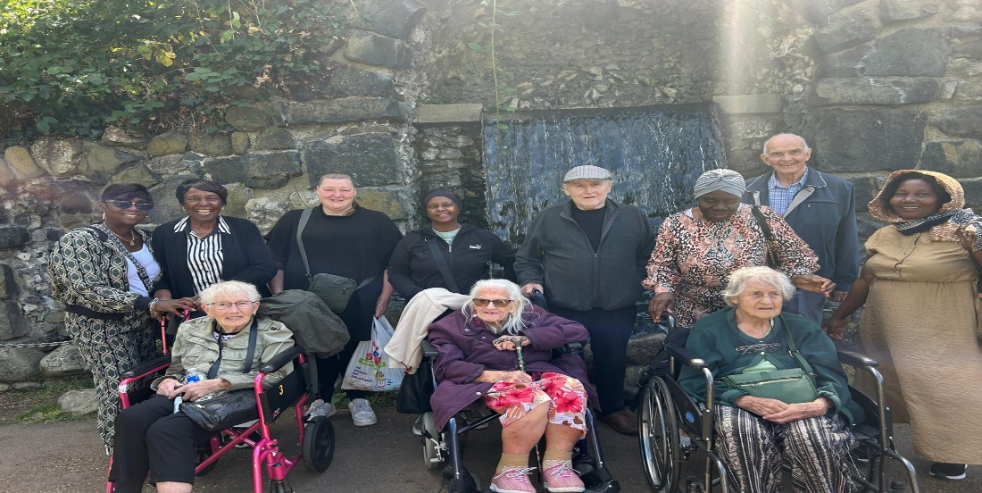

Activities in August included Boat Trip to Windsor, and Chiswick Carnival Mask Making, Jamaica Independence Celebration and many more

