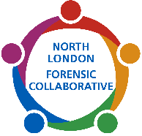
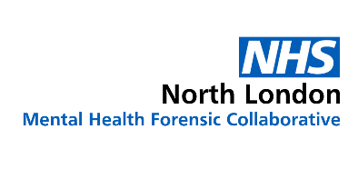

North London Forensic Collaborative
Meaninful Activities Grant (LDA Services) Application Form
- Organisation Details
1.1 Organisation Name:
1.2 Organisation Address:
1.3 Organisation Postcode:
1.4 Status of organisation (Registered Charity, CIC, Social Enterprise etc.)
1.5 Company/Charity Number Registration if applicable:
1.6 Vat Number if applicable:
1.7 Organisation Start Date:
1.8 Main Contact:
1.9 Job Title/Position in the Organisation:
1.10 Telephone Number:
1.11 Email Address:
1.12 Organisation Purpose and Role: | Describe the overall aims and objectives of your organisation and the services your organisation provides. (Max 150 words)
1.13 Where did you hear about the NLFC Meaningful Grant:
- Eligibility Criteria | Applicants must evidence that they are a VCFSE (above) and meet the following criteria checks for the application to be considered
- Currently operating in NLFC geographical area, or neighbouring borough. | Name of borough/area covered:
- Please tick which applies to your organisation | - Currently working with people who use forensic mental health services with a learning disability and/or autism and would like to increase or enhance the offer ☐  - Currently delivering a service/project which we would like to extend to people who use forensic mental health services with a learning disability and/or autism ☐
- Proposal is aimed at forensic mental health service users | Confirm your project is targeting people who use forensic mental health services with a learning disability and/or autism under the care of one of the services in NLFC (please note we cannot fund projects aimed at other population groups).  Yes ☐
- Grant Application
3.1 Please describe the project you are looking to fund
(Max 100 words)

3.2 If you have ticked item 1 in section 2.2, please describe what you currently offer service users and what this additional funding will be used for
(Max 100 words)
3.3 Please describe your track record in delivering a similar project, to people who use forensic services, people with a learning disability or autistic people, or other marginalised groups
(Max 100 words)
3.4 How will this project benefit people who use forensic mental health services and how will you measure success

(Max 300 words)
3.5 How many service users will benefit from the additional funding | Number of Service Users:
3.6 Project Support: Please tell us any support you may need from the commissioning team or providers to better enable you to mobilise and embed the project

- Project Budget and Timescales
4.1 Grant Amount | How much money are you applying for: £
4.2 Budget Breakdown | Please provide a breakdown of the cost of your project:
4.3 Timescale | When will the project start and finish:
4.4 Previous Funding Requests | Provide detail of any grant money received as part of the NLFC Grant Programme in the last 12 months:  Please note total grant funding that can be awarded per provider per rolling year is £9,999.00 (this includes the NLFC VCFSE Small Grant Programme and the Meaningful Activities Grant for LDA Services)
- Declaration
By submitting this application to NLFC, you certify that the information declared in the application form is correct, and if awarded the grant, you will only use it for purposes described above. You understand that decisions made by NLFC are final.

Print Name:

Signature:

Please email your completed application form to: beh-tr.nlfc@nhs.net
You will receive email confirmation of the outcome of your application within 8 weeks of submission. If you are successful, we will arrange a pre-meet with you before the grant is awarded, to agree terms of the grant and a date for the follow up 3-month meeting.
If you have any queries, please email Serena McCabe: NLFC Partnerships Manager. Serena.McCabe@nhs.net

