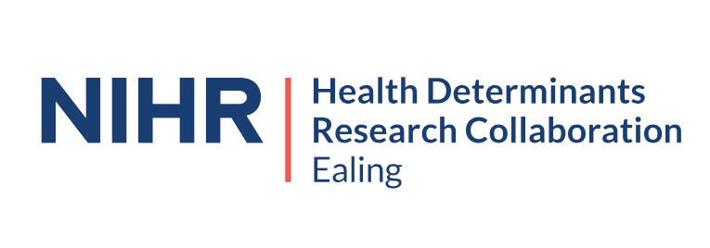
We are looking for 2 Community Group Representatives on the Health Determinants Research Collaboration (HDRC) Ealing Programme Board

About the Ealing Health Determinants Research Collaboration
Ealing is a highly diverse and vibrant borough in the west of London. Home to around 370,000 people, it is the third-largest borough by population in London and is an exciting, diverse, and challenging place to live and work. There are stark and longstanding inequities in health determinants – the ‘building blocks’ of health – like education, social connection, housing, and good jobs. This leads to poorer health and shorter lives for disadvantaged communities.
In its commitment to addressing health inequities, the council has been awarded £5 million from the National Institute for Health and Care Research (NIHR) to create the NIHR Health Determinants Research Collaboration Ealing. This initiative aims to develop the capacity and infrastructure for meaningful research on the health determinants in Ealing, with the goal of promoting more healthy, thriving, and equitable communities.
As a partnership with local community organisations, Ealing and Hounslow Community and Voluntary Service, Golden Opportunities for Skills and Development, Southall Community Alliance, and research institutions London School of Hygiene & Tropical Medicine, Imperial College London, and the Institute of Development Studies, the HDRC Ealing will bring a new approach to collecting and learning from data and insights on the building blocks of health, with stronger community participation and involvement in research.
With the HDRC Ealing capacity and infrastructure developing and sustained, we are committed to learning how to promote healthier, thriving and equitable communities together. Your involvement in this journey is crucial, and we are optimistic about the positive impact we can make together.
Purpose of the Role
These Community Group Representatives will play a pivotal role in ensuring that the views and needs of Ealing’s diverse community are effectively represented on the HDRC Ealing Programme Board. This role is not just a link but a crucial bridge between HDRC Ealing and the community, advocating for inclusive and equitable research practices that address the building blocks of health within the community. Your involvement is key to our success.
Key Responsibilities
- Strategic Advocacy and Representation, actively representing the interests and perspectives of communities in Ealing in Board discussions, ensuring their needs are considered in decision-making processes related to the health determinants research collaboration.
- Communicate effectively with community groups about the developing new capacity, expertise, and infrastructure to do research, board decisions, and opportunities for involvement.
Qualifications
- Voluntary Community Sector Group based in Ealing.
Experience:
- Experience in community engagement, health advocacy, or a related field, with a strong understanding of health determinants and equity issues.
Skills:
- Excellent communication and interpersonal skills.
- Strong advocacy and negotiation skills.
Knowledge:
- Deep understanding of the local community’s health challenges and opportunities.
Attributes:
- A passionate advocate for health equity and community empowerment.
- Proven ability to work collaboratively with diverse groups and stakeholders.
- Interest and commitment to research
Commitment:
- The role requires active participation in regular and ad hoc programme board meetings, likely to be 60-90 mins long every 2-3 months, online or in person, and may require some preparation for these engagements, and follow up actions including ongoing communication with community groups and stakeholders. This commitment will be for an initial period of a year, with potential to extend this, following a review of the governance processes.
- The programme will be able to reimburse for your time and expenses.

To apply please complete the application form and send it to Gurpreet Rana: gurpreet@ehcvs.org.uk before Friday 7th June 2024.

Application Form for Community Group Representative

Part 1: Personal Information
Full Name

Contact Information | Phone
 | Email
Preferred Method of Communication (Email, Phone, Text)

Address

Part 2: Background Information
Languages Spoken

Accessibility Requirements (to ensure all interviews and meetings are accessible)

Part 3: Relevant Experience
3.1 Current Employment/Role (if applicable)

3.2 Experience with Community Engagement

3.3 Describe any previous roles or volunteer positions you have held that involved working with or representing a community group.

3.4 Experience in Health Advocacy or Related Fields

Part 4: Motivation and Understanding
4.1 Motivation for Applying

4.2 Why are you interested in this role? What motivates you to represent your community on the HDRC Ealing Programme Board?

4.3 Understanding of Community Needs

4.4 Based on your experience and knowledge, describe the key health determinants impacting your community.
Part 5: Vision and Impact
5.1 Vision for the Role

5.2 What do you hope to accomplish as a Community Group Representative on the board?

5.3 Community Impact

5.4 How do you believe your involvement on the board will benefit the community? Provide specific goals or outcomes you aim to achieve

Part 6: References
 | Name | Relationship | Contact Info
Reference 1
Reference 2

Part 7: Additional Information
Any additional information or comments you would like the selection committee to consider.

Part 8: Declaration and Consent
☐Confidentiality Agreement to ensure that all application discussions are kept confidential.
Consent to Process Information:
☐I consent to having my information processed for this application.

Signature:

Date:

For any queries please contact Gupreet Rana: gurpreet@ehcvs.org.uk

