**About Clementina Day Centre**

Clementina Day Centre (CIC) is an independent, non for profit community organisation, which provides older people who may be lonely, isolated or diagnosed with Dementia a safe, fun and engaging environment where they can participate in activities and socialise with their peers.

We specialise in supporting people diagnosed with Early Onset Memory Loss, Alzheimer’s and Dementia. The day centre also welcomes anyone who is 60+ who feels lonely or isolated.

We operate for public benefit rather than private gain and all our projects and services are designed, developed and  built to support the needs of those living with dementia and their families.

**The Team**

The team is led by its founder and social entrepreneur Jennifer Forrester, who is a qualified social worker with 30 years experience.

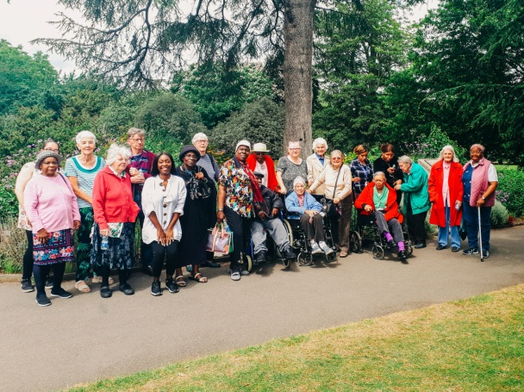

Jennifer is supported by:

Laura – Admin

Wendy – Senior Support Worker

Monica – Senior Support Worker

Joanne – Volunteer

We are a dedicated team who share an ethos of compassion, kindness, fun and care.

Training:

Clementina staff are trained and DBS checked. Staff undertake training in subjects including (but not limited to):

Safeguarding Adults, Care Act, Effective Communication, Introduction to Dementia, Duty of Care, Working with clients who lack capacity, Autism Awareness, Person Centred Care and Dementia, Learning Disahility Awareness, Mental Health Awareness.

**Our partnerships**

Clementina Day Centre works in partnership with



**Transport**

Clementina staff can make a referrals for Ealing Community Transport or Dial-a-Ride services which will provide transport to and from the day centre.

*Anna Whitty MBE, Chief Executive at ECT, says …a key part of ECT’s charitable aim to support local organisations in ending social isolation. “We really value partnerships like the one we have with the Clementina Day Centre,” says Anna.*

**Referrals**

We receive and accept referrals from: Dementia Concern, Memory Clinics: Elm lodge and Sycamore lodge, Care Co-Ordinator’s at Ealing Community Partners, London Borough of Ealing Social Services and self-referrals.

**Support Offered**

We are committed to providing people a fun, safe and engaging environment where day centre members can participate in activities and socialise with their peers. Our mission is to provide day centre members with: A person centred environment that is responsive to individual needs and interests, assistance to retain skills and abilities, assistance to build on confidence and self-esteem, assistance to promote and maintain the ability to socialise and reduce isolation.

We are also committed to *'providing support for carers'* as we recognise the need for carers of older people and those who have been diagnosed with Dementia, to be offered respite and have a break in order for them to look after themselves and meet their own needs.

**Fees**

Daily Fees to attend the day centre which include breakfast, two course lunch and activities, personal care and one to one support (If required)

Please contact us to for further information re prices

**Aims**

- Support for Dementia care / supporting elderly day care (and young dementia)

- Assistance to retain skills and abilities, physical exercise, brain stimulation

- Build confidence and self-esteem

- Promote and maintain the ability to socialise and reduce isolation

- Build new friendships and relationships

- Assisting community cohesion by providing work experience / volunteering opportunities

- Providing work experience opportunities to students across the borough who attend special education needs schools.

**What our day centre members say about**

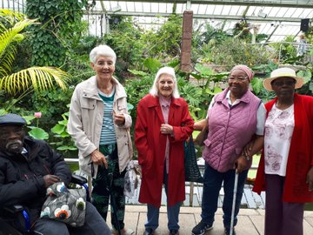**Clementina Day Centre**

Jean S “I can get out and do something I enjoy”

Jean D “ Oh, they are so good to me!”

Mary P “Yes! I enjoy my day”

James D “Everybody looks after me”

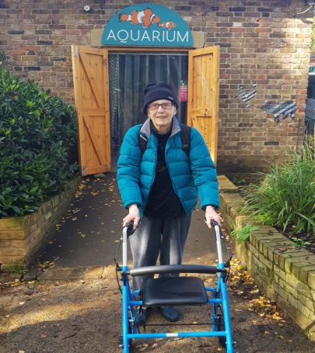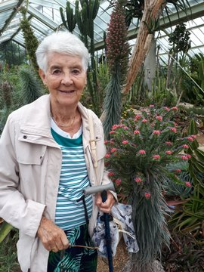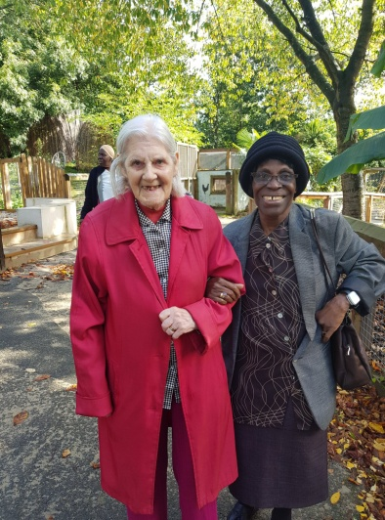

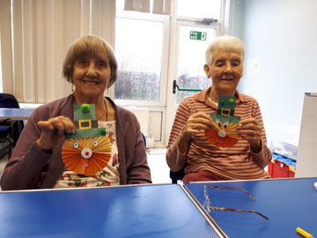

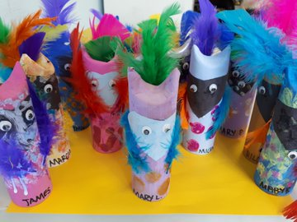

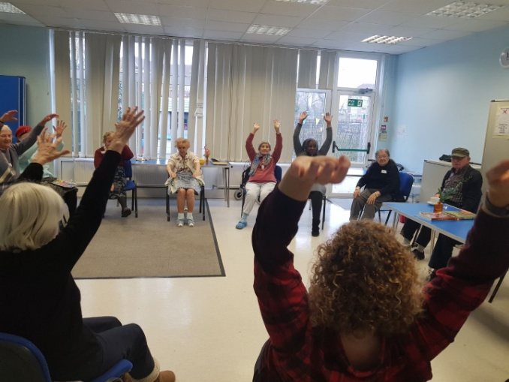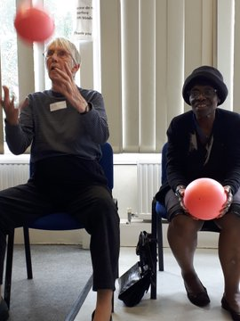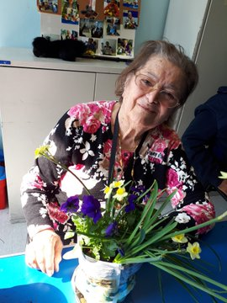

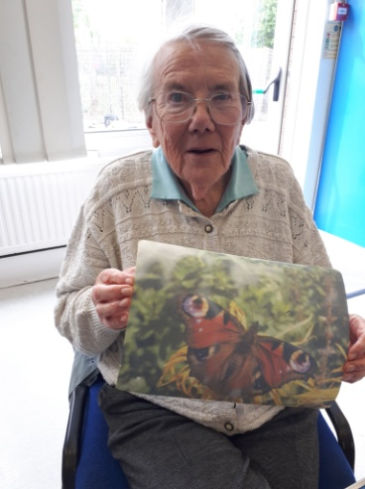

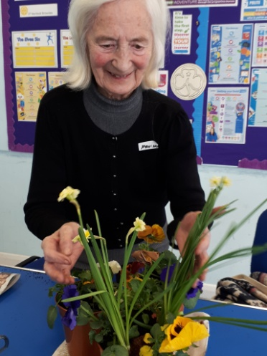

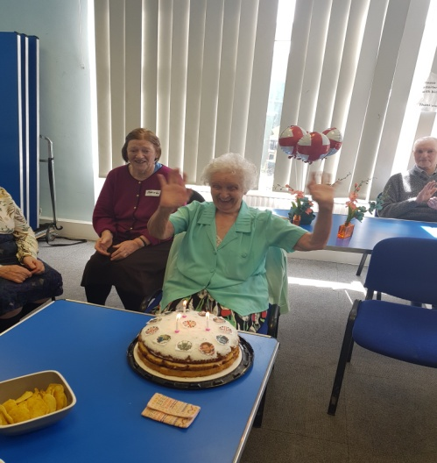

**Example of Activities (below activity schedule)**

|  |  |  |
| --- | --- | --- |
| Monday 9 September  Related imageThe Price Is Right  guessing game | Paintbrush with blue paint dipped into a jar filled with water against white background Stock Photo - 74747641Tuesday 10 September  Aqua Painting | Friday 13 September  Image result for bowling  Bowling |
| Monday 16 September  https://images-na.ssl-images-amazon.com/images/I/91I70DKBU2L._SL1500_.jpg  Van Gough Plate Painting | Image result for bingoTuesday 17 September  Bingo | Friday 20 September  Relax Free Time |
| Image result for cookieMonday 23 September  Baking | Tuesday 24 September  Image result for invention  Year of Invention  guessing game | Friday 27 September  Image result for people paintingPainting and creativity |
| Monday 30 September  Balloon Tennis | Hanwell ZooTuesday 1 October  **Hanwell**  **Zoo Trip** | Friday 4 October  Relax Free Time |
| Monday 7 October  Image result for bowling  Bowling | Tuesday 8 October  Jigsaw puzzles | Friday 11 October  Image result for cheese  Cheese Game |
| Monday 14 October  Related image  Bingo and Games | Tuesday 15 October  Relax Free Time | Friday 18 October  Image result for flowers  Flower  Arranging |
| Image result for people paintingMonday 21 October  Painting and creativity | Tuesday 22 October  **Day Trip to Kew Gardens** – Tool Shed workshop & Health Walk | Image result for bowlingFriday 25 October  Bowling |
| Paintbrush with blue paint dipped into a jar filled with water against white background Stock Photo - 74747641Monday 28 October  Aqua Painting | Tuesday 29 October  Image result for halloween  Halloween Creativity | Image result for bingoFriday 1 November  Bingo |
| Monday 4 November  Relax Free Time | Tuesday 5 November  Image result for people paintingPainting and creativity | Friday 8 November  Image result for cheese Cheese Game |
| Monday 11 November  **Image result for casablanca movieBeck Theatre**  Casablanca  Movie Screening | Tuesday 12 November  Related imageBingo and Games | Friday 15 November  Paintbrush with blue paint dipped into a jar filled with water against white background Stock Photo - 74747641  Aqua Painting |
| Monday 18 November  Image result for cheese  Cheese Game | Tuesday 19 November    Plate Painting | Friday 22 November  Relax Free Time |
| Monday 25 November  https://images-na.ssl-images-amazon.com/images/I/91zBLMYBGTL._SL1500_.jpgReminiscence Box  Morning | Tuesday 26 November  Image result for chocolate rice krispie cakesMaking Chocolate rice krispie cakes | Friday 29 November  https://images-na.ssl-images-amazon.com/images/I/91zBLMYBGTL._SL1500_.jpgReminiscence Box  Afternoon |
| Monday 2 December  Image result for bowling  Bowling | Tuesday 3 December  Relax Free Time | Image result for christmas lightsFriday 6 December  **Christmas Lights of London Trip** |
| Monday 9 December  Making Festive Cards | Related imageTuesday 10 December  Bingo and Games | Friday13 December  Making Festive Cards |
| Monday 16 December  Image result for christmas decoration  Making decorations | Tuesday 17 December  **Beck Theatre**  Image result for sleeping beautySleeping Beauty Pantomime | Friday 20 December  Singer Eddie Shaw for Festive Party  Image result for singer cartoon |
| Clementina Team xx | | |