 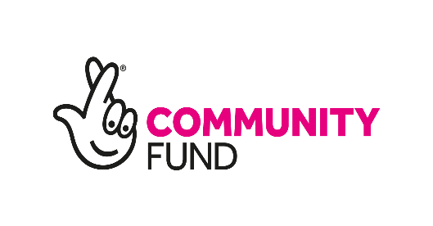

LOCAL CONNECTION

LEARN TO SWIM START SEPTEMBER 6 th

Every Monday: 10-45am till 11-45 am@ Heston Hyde Hotel

North Hyde Lane

Hounslow TW5 0EP

*Only for people with disabilities first come first serve*

*To book your sessions contact*

*Sharnjeet: 07878990874*

*sunshineofhounslow@gmail.com*

